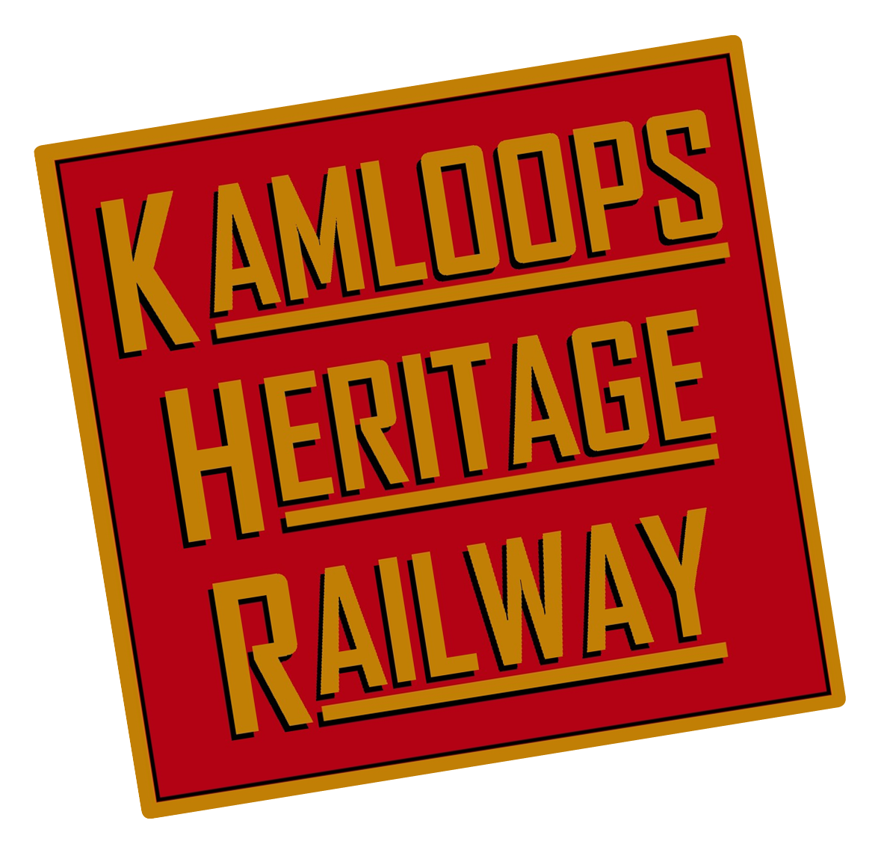
KAMLOOPS HERITAGE RAILWAY SOCIETY
Annual General Meeting – THURSDAY, October 15th, 2020 6pm
STRATA MEETING ROOM, 490 Lorne Street, KAMLOOPS, BC

Board Members Present: Karla Karcioglu, Nicholas Adams, Norm Glass, Shirlee Ezowski, John Wozlowski
Zoom - Robert Samson
Absent - Glen Wideman
ATTENDING MEMBERS: 24
(12 In Person and 12 via Zoom)

Members are reminded that they needed to be fully paid up members in order to vote on items tonight

The Meeting was called to order at : 6:02pm

Norm Glass welcomed members to the 2020 AGM; he stated the last AGM was September 23 2019 and introduced the board members in house and via zoom.

1. PRESIDENT’S REPORT – Karla Karcioglu
Karla: This year has been a collaborative effort by the board and the board has achieved a strategic Plan which will be presented by Cory Clark.
Nick Adams and Shirlee Ezowski have completed their term; only Shirlee is seeking nomination.
I am also resigning effective tonight and Norm has taken the role as acting president for the past 2 weeks.

I look forward to seeing the growth of the society in the future. The past year we (the board) invested a lot of time and energy into future planning. One of the things I noticed as president was the need for more focus into processes so that we can be a successful society and that is the strategic plan.

I would like to thank all the volunteers and members who are very committed to your time and energy. There are endless names to thank this year but particularly Doug Peterson, with Covid shutting down the backshop. Doug stepped up as our grounds keeper and did a great job looking after the facility. The other notable changes was the restructuring of our staffing model by hiring Cory Clark as our Executive Director as we identified KHR had higher level issues and we needed better focus on grant writing and strategic planning.

KHR was not prepared for the pandemic but we have managed to have low overhead which helped our finances. It was a heartbreaking decision to close down the backshop.

This AGM is a review of 2019 but we understand and have prepared for the members to have questions about the 2020 year and the financial health and planning.

We all miss the train but the health and safety of our staff and volunteers is more important.

2. SAFETY REPORT - Russ Grycan
Russ - Congratulations to KHR for a great season. We had 6,900 guests on the train and had no incidents. There were a couple of little trips but no safety issues relating to our guests. We have safety meetings and emails with safety information that still go out. Anytime you are around railways you have to be aware of the safety advice and rules.

Next year there will be 5 to 10 coal trains added to the already busy route and now more than ever it's important not to cross the tracks and if you know anyone who does cross the tracks it's a $160 fine. CN is one of our partner’s and both CN and CP focus on Safety.

Everyone at KHR helps to keep people safe, our onboards did a good job making sure everyone obeys the rules around train safety and at the backshop we keep up our certifications to ensure all the procedures for safety checks are followed.

KHR is well respected by Transportation Canada and Technical Safety BC. We get the job done and we get it done safely. We are always subject to inspections and we have monthly safety meetings, pre departure inspections and do an outstanding job in keeping everyone safe. Thank You to Norm and Doug for keeping the grounds safe and thank you all for your help.

3. STRATEGIC PLAN PRESENTATION - Cory Clark
Cory - For those of you who have not met me I am the newly appointed Executive Director. The strategic Plan took the board many months to create and it was a chance to see what we were doing well and where we needed to improve.

Our Missions statement - The mission of the Kamloops Heritage Railway is to maintain railway history including steam locomotive 2141 and other rolling stock by providing a variety of safe experiences that educate, entertain and enrich the lives of our guests, volunteers, partners and the community.

Educate, Entertain and Enrich in everything we do.

Our Vision statement - To inspire future generations to enjoy and preserve railway history.

Our service agreement with the City of kamloops is that they will help fund 40 trips per year. There is no funding for special trains that are chartered for weddings, all of the 40 trips must be open to all of the public.

As well, CN only allows us for 40 trips per year and might entertain the idea of an added train but it is highly unlikely they will allow it. So KHR are limited to 40 trains per year.

Potential hurdles: The coal trains next year; Robert Samson and I visited the CN yardmaster and they indicated 10 trains a day and switching loco’s meaning more delays. We will have to be flexible with our times and 40 trips to accommodate this.

Covid 19 was a huge factor this year. We are in phase 4 of the BC re-start plan which is a vaccine and effective treatment available before we can operate. With the City of Kamloops aiming for a 0% tax increase for 2021 we are preparing for the service agreements to be affected next year and we are holding money over for start up in the event we receive a decreased amount on our service agreement.

Existing Challenges: WiFi, Technology and Computers. Volunteer Recruitment. Space and Infrastructure; we are very limited for space at our backshop facility. Rolling stock is also aging out and will need to be replaced. Multiple locations with our ticket office and backshop operation has adverse effects on communication and team building opportunities.

Projects and Goals: Back shop tours - we have re-developed our back shop tour experience and just launched the new tour. We had our first tour last week and thanks to Gary and Ainslee we received high praise and resulted in a $150 donation. The Static Displays for the tours are still rolling out, we have Mike, Norm, Doug P and Glen building up our interactive displays and model train as well as have James Howe helping with augmented reality in the future which will allow you to scan cards and bring up information of what life was like, some exciting new technology to introduce to KHR.

The Spirit of Kamloops rail experience will be having some changes, we will be moving away from the dancing girls and concentrating on actors that will be a part of the interactive experience improving the commentary and overall experience to help the train become more profitable.

Another change is the Cafe Lounge will be a part of every consist we do, it's a great opportunity for a gift shop and to sell snacks to help create new revenue streams. We are also trying to investigate a Golden Ticket to ride the cab with the engineer. We are still working with our engineers and insurance on the idea.

The Education Program: We are dedicating space in the 406 railcar for a classroom that will be reminiscent of the 1920-1930’s school room rail car to offer school excursions to share the history. This can be a virtual classroom also to expand the KHR experience during Covid times and to invite overseas rail enthusiasts a chance to see our programs.

Volunteer Recruitment: there is a great need to transfer the knowledge of the current volunteers to more volunteers. We are targeting specific skills like actors, engineers etc. It's also important to retain our current volunteers and make sure they feel appreciated.

Goals: Backshop tours are currently under 200 people per year, our 5 year goal is to reach 2,000 people per year.
The Spirit Of Kamloops loses $300 per trip, in 5 years we want to make $500 per trip.
The Education program currently has 0 participants due to it being new and in 5 years we want 500 students per year participating.
Volunteers; we would like to double our volunteer numbers in 5 years.

Additional areas to focus: Fundraising - we are a charitable society that does very little fundraising. Online presence - our data research indicated people find us on social media so expanding on a marketing plan to take advantage of that. Document Management - KHR struggles with not having a centralised document system in place we are trying to resolve. Communication Plan - making sure the information gets out to the right people by centralising the point of contact. Archives - improving our archiving system which Leslie and Robert hall have volunteered for.

Future goals: Central Base of Operations. New revenue stream e.g. Mini Rail and a Second Route - Armstrong, Robert Samson is working with Transport Canada to see if we can get that trip going again.

This is a very condensed version of the Strategic Plan if anyone would like the full version I can email it to them its about 40 pages and takes a deep dive into guests comments and other analysis of the society.

4. FINANCIAL REPORT - Cory Clark
Income Statement 2018 compared to 2019 and Balance sheet ending Dec 31 2019 distributed.

Income statement: there was a notable difference in ticket sales of $6,000 down from 2018 this was a direct result of not having a Ghost Train in 2019. Although we did do halloween trains they were more children appropriate and children tickets are a lot less expensive. The Ghost Trains sell out and are full of Adult Tickets. We will definitely be reinstating the ghost train in 2021.

Notable difference in Cash donation as we had a $80,000 estate donation in 2018 for the 2141 engine. The difference in Wages, we went from seasonal staff in 2018 to full time staff in 2019.

Balance sheet: Railtour Account and Society account are healthy. The Term deposits we have are for the contingency engine fund that we have a contractual obligation with the City of Kamloops to put aside in the event of a large repair.

As the Covid 19 pandemic continues we have made projections and budgeted for the first few months of 2021 and start up money for the upcoming season. This was largely possible because of the wage subsidy program from the government and Walmart donated $1,000.

Q. Russ - Is the depreciation included in the rolling stock Value?
A. Cory - No, it's not included in the Income Statement.
(Depreciation is done by our accountant each year as a business expense)

Motion to accept the Financial Report (Nick Adams)
Approved

5. PROPOSED BYLAW CHANGES
Section 2 - States Manager will have 2 directors as Supervisors - we need to add Executive Director and or Manager

Add 2 new recipients for Lifetime Membership

Motion to accept the proposed Bi law changes (Karla Karcioglu)
Approved (unanimously)

6. MEMBERSHIP REPORT - Karla Karcioglu
The Lifetime Membership is awarded to a member that has volunteered a great number of years to the society and done an outstanding job. Tonight we recognise two members who the board has deemed suitable for the Lifetime membership and they are:
Gordie MacDonald - who drives the engine and has worked tirelessly over the years for the society and
Kerry Spear - -who has been with KHR from the start and has been volunteering for over 2 decades.

Thank you and Congratulations.

7. Directors Elections - Norm Glass
Resignation prior to the AGM
Glen Wideman

Completed Director Terms
Shirlee Ezowski, Nick Adams

Resignation at AGM
Karla Karcioglu

Entering the Second Year of their Term
Robert Samson, John Wozlowski, Norm Glass

Seeking Nominations for the Board of Directors
Shirlee Ezowski, Russ Grycan, David Jackson, Cathy McKensie

Norm: We have 4 open positions and 4 nominations for the board positions. At this time I will call for nominations from the floor and Zoom?
No new nominations.

General Vote -Please show your cards if you approve the new board in house and Zoom.
Approved

Norm: Welcome to the new board and a special thank you to Karla, Nick and Glen for all of your work.

Two Motions to pass (Tom via Zoom) Norm Glass
- Society is seeking a credit card of $1,000 to limit volunteers and staff using personal cards. The Bylaw states we need a vote. This card will be paid off each month and be in the name of the Executive Director.
Q. Nick Desimone - how will it work when i need to buy things?
A. Cory - there will be times when we use the card or I can go with you to the store or you can still use your own card.

Motion : All in favour of the Credit card with the $1,000 limit?
Approved

- KHR would like to pursue the government endorsed $40,000 loan announced under the covid recovery business plan. If we pay it back in two years we only have to pay back $30,000 and it is 0% interest which is essentially $10,000 grant money.
Q. Nick Desimone - How do you want to spend the money? We should be careful to go for a loan without a plan.
A. Cory - The new board will give more directives but we will use it for upcoming large expenses like moving the 406 which we know will cost $15,000 and the static display and other revenue generating projects.
Karla - the loan is available now so we really would like to take advantage of the loan.
Q. Silvia via Zoom - can we pay it off?
A. Cory - we are confident we can easily pay it back in the time frame.
Q. Russ - so we borrow $40,000 and only have to pay $30,000?
A. Nick Adams - Yes it's Government backed so we don’t have to use any collateral and have 2 years to pay it back and only pay $30,000 if we don't pay it off in time we pay the full $40,000 at 0%.

Motion: All in Favour to accept the Loan
Doug Peterson - Second
Approved (unanimous)

Cory - just before we end I want to thank Karla, without your spending freeze motion we would not be in the financial position we are in, you have worked tirelessly to create change.
To Nick Adams your knowledge will be sorely missed and we thank you for your time.
And to Glen Wideman, we talk daily, you are a wealth of information and we thank you for everything.

Q. Nick Desimone - usually we have a backshop report we didn't do this year, we do a lot of things back there that should be reported.
A. Cory - Doug Ball is the Foreman of the backshop and he recently resigned from the position so there was no available report, he will still be a volunteer and we will need to appoint a new foreman soon and will likely send a backshop report via email.

Norm: I want to make special mention to Doug Peterson who has taken on the larger projects and is a tireless volunteer and help to the society.

Meeting adjourned 7:04pm

